**Carti Hotel Management System**

**Use-Case Specification: Manage User**

**Version <1.0>**

# Revision History

|  |  |  |  |
| --- | --- | --- | --- |
| **Date** | **Version** | **Description** | **Author** |
| 24th Nov 2024 | Version 1.0 | Final version | Tran Quang Huy |
|  |  |  |  |

**Table of Contents**

Revision History 2

Use-Case Specification: Manage Users 4

1. Manage users 4

1.1 Brief Description 4

1.2 Actor 4

2. Flow of Events 4

2.1 Basic Flow 4

2.2 Alternative Flows 7

3. Special Requirements 7

4. Preconditions 7

4.1 Add user 7

4.2 Update user 8

5. Postconditions 8

6. Extension Points 8

7. Prototype 8

# Use-Case Specification: Manage Users

## Manage users

### Brief Description

This use case outlines the procedure for user management, encompassing the addition of a new user, updating existing user information, and deleting a user, be it a customer or a receptionist.

### Actor

Administrator

## Flow of Events

### Basic Flow

* + 1. ***Add user***

On the Admin Page, the navigation bar includes several functional buttons such as Home Page, Category, System, Report, Users, Facility, and Rooms. The hotel's room statuses are depicted using different colors: green signifies "Vacant Ready," purple indicates "Being Cleaned," and red represents "Busy."

To manage users, the administrator hovers over the Users button in the left-side menu and selects the Add User option, which redirects them to the Add User Page. On this page, the admin can opt to add either a new customer or receptionist by entering the necessary user information. The process is finalized by clicking the Save button. If the user does not already exist in the system, the new user is added, and a success message is displayed. If the user already exists, an error message is shown.

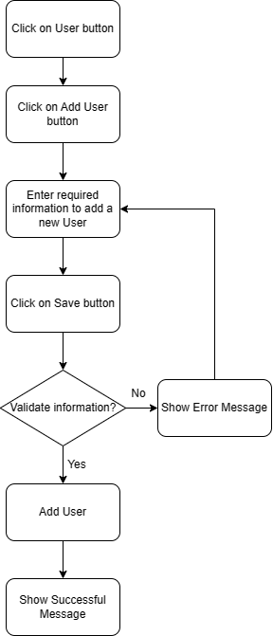

* + 1. ***Update user***

On the Admin Page, the administrator goes to the Users section and selects the Update Button. This action allows the administrator to directly edit the user's information within the user list.

To modify a user, the administrator clicks on a specific user in the list, which redirects them to the Update User Page. Here, the admin must enter the required information for the update and click the Save Button to complete the process. If the entered information is invalid, an error message appears, prompting the administrator to correct the details and attempt the update again.

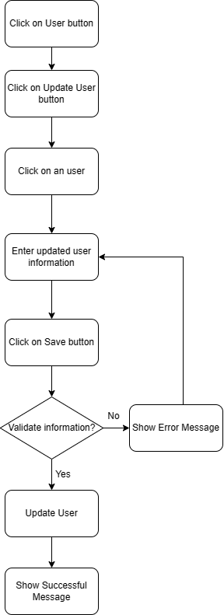

* + 1. ***Delete user***

On the Admin Page, the administrator starts the user deletion process by clicking the Users Button. This action navigates the administrator to the Delete User Page, where a complete list of all users is displayed.

When the administrator selects a user, a confirmation dialog appears. If the administrator confirms the deletion, the chosen user is permanently removed from the system. If the administrator chooses to cancel, they are returned to the Delete User Page without any changes. This confirmation step ensures that the administrator deliberately intends to delete the user.

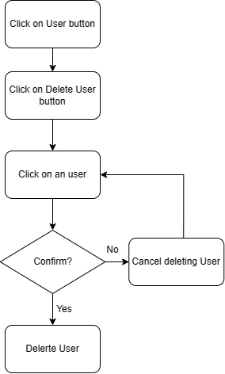

### Alternative Flows

None

## Special Requirements

None

## Preconditions

The user has logged in successfully with the administrator role.

### Add user

The user is not currently present in the database, and all attributes of the new user are valid.

### Update user

All attributes of the updated user are valid

## Postconditions

All information about the new user, the updated user, and the deleted user is updated on the database.

## Extension Points

NA.

## Prototype

In the Admin Page, there are some functional buttons on the navigation bar such as Home Page, Category, System, Report, Users, Facility, and Rooms. The remaining part displays the status of rooms in the hotel.

The darkest blue color with the status “Vacant Ready” means this room is willing to welcome customers. The grey color means this room is being cleaned. The lightest blue color means this room is busy. Admin hovers on the Report button and then clicks on the Revenue Report. To manage users, the admin hovers on the Users Button, after which 3 options will show up: Add User, Delete User, Update User.

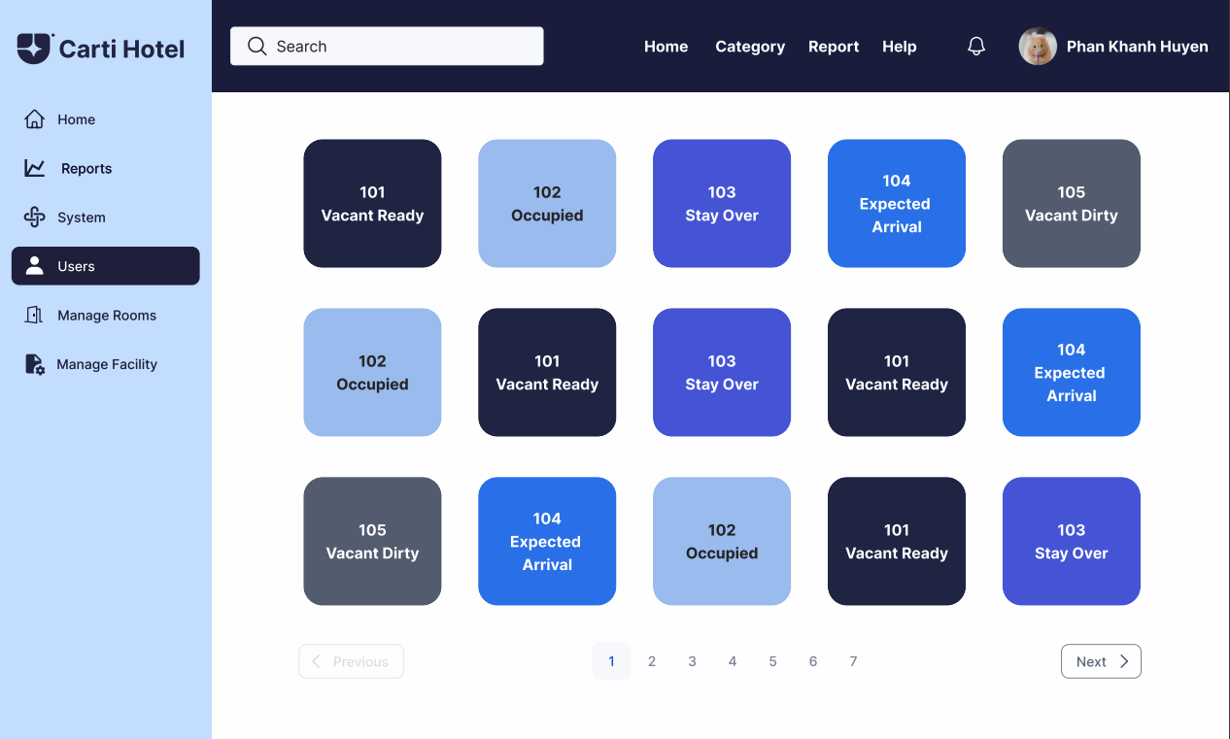

The admin is required to click on the Users button on the left side, and after that click on the Add User button.

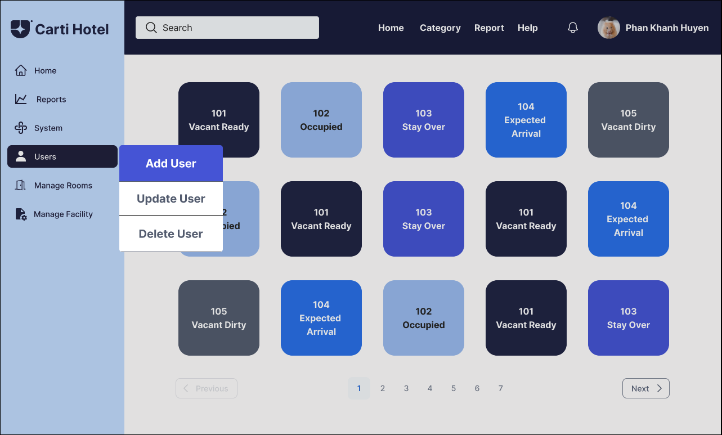

The admin will be navigated to the Add User page. Then, the admin is required to input information into a form to add a new customer. If the input data is valid, at the end of each block will appear a green tick, otherwise, a red cross will appear. Below on the right-hand side of the form is the Save button with the same color as the main dark blue color of the website.

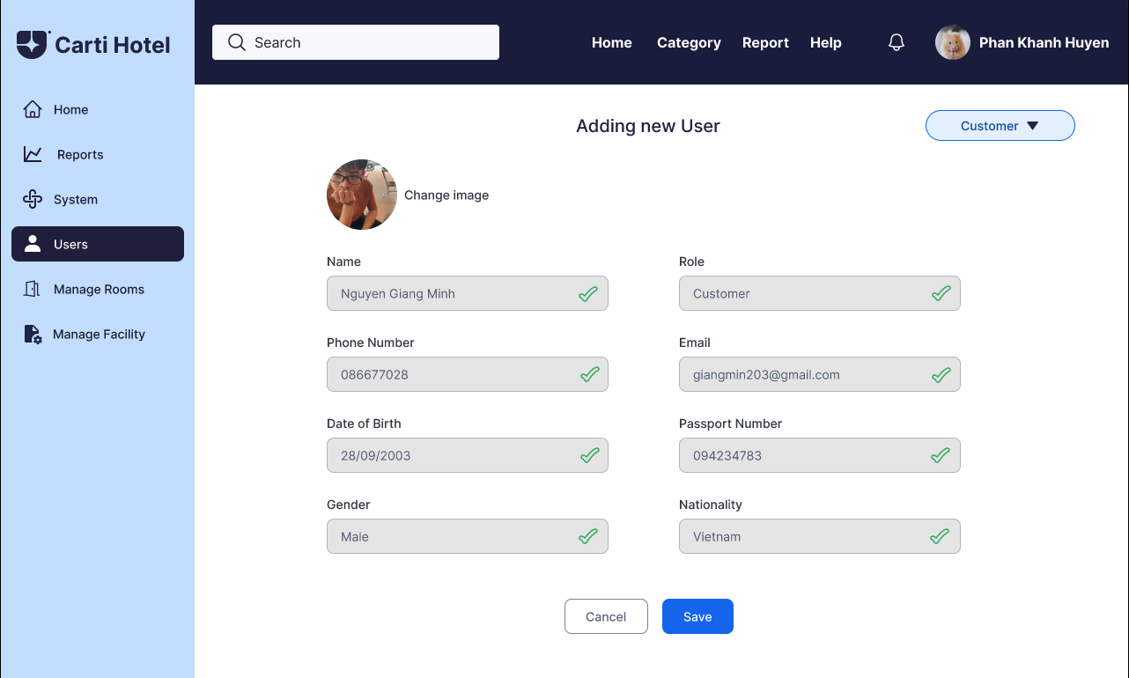

If the admin wants to add a new receptionist, he/she chooses the option Add Receptionist in a drop down menu above the form, and then all the user’s required information will be switched to receptionist information.

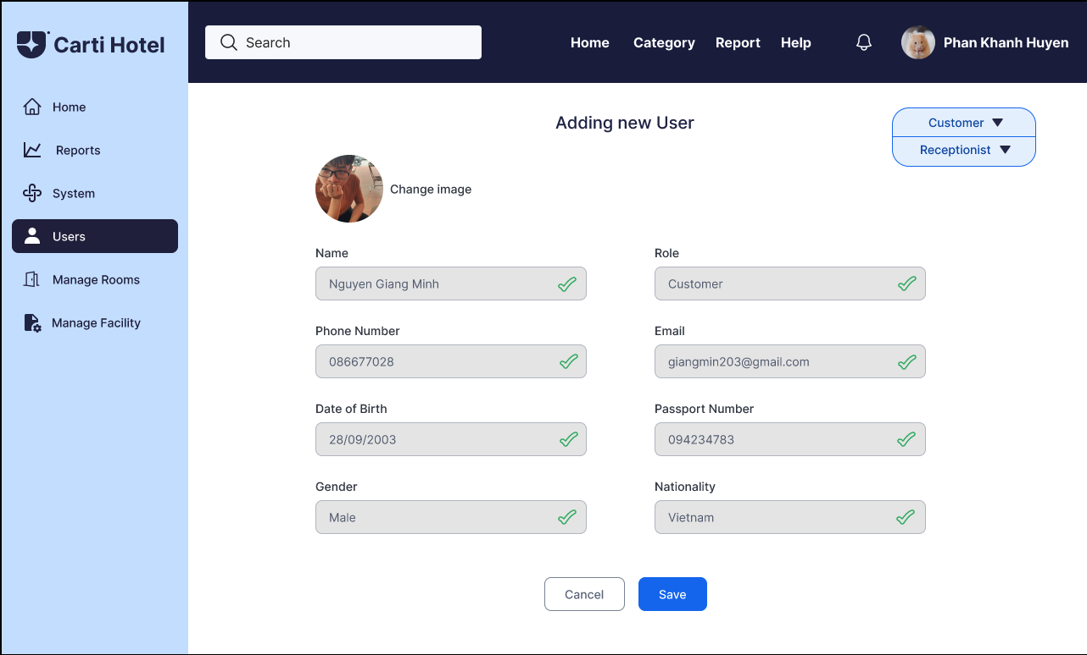

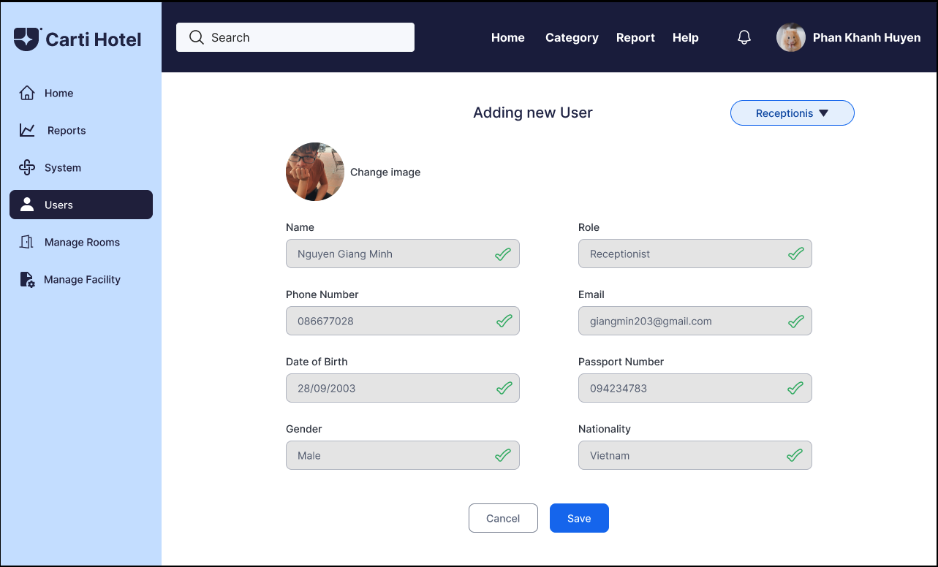

After inputting all the required information, the admin clicks the Save Button. A square success message box will be shown if nothing goes wrong.

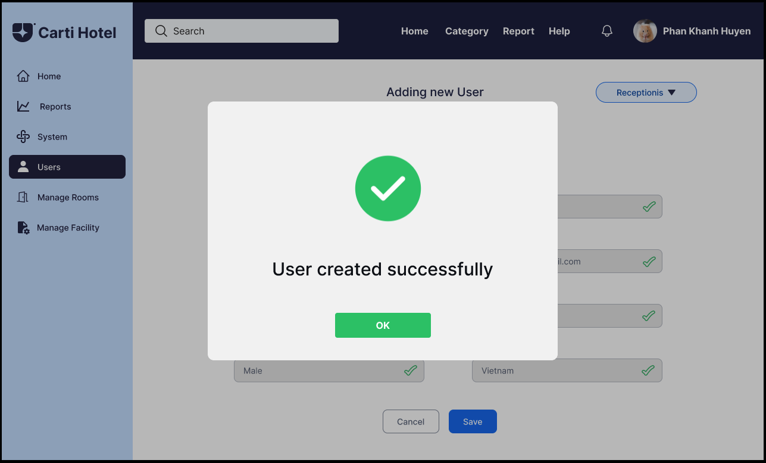

To update or delete an existing user, on the homepage, after clicking the Users Button.



Three options to manage users will appear and the admin must click the delete user button.

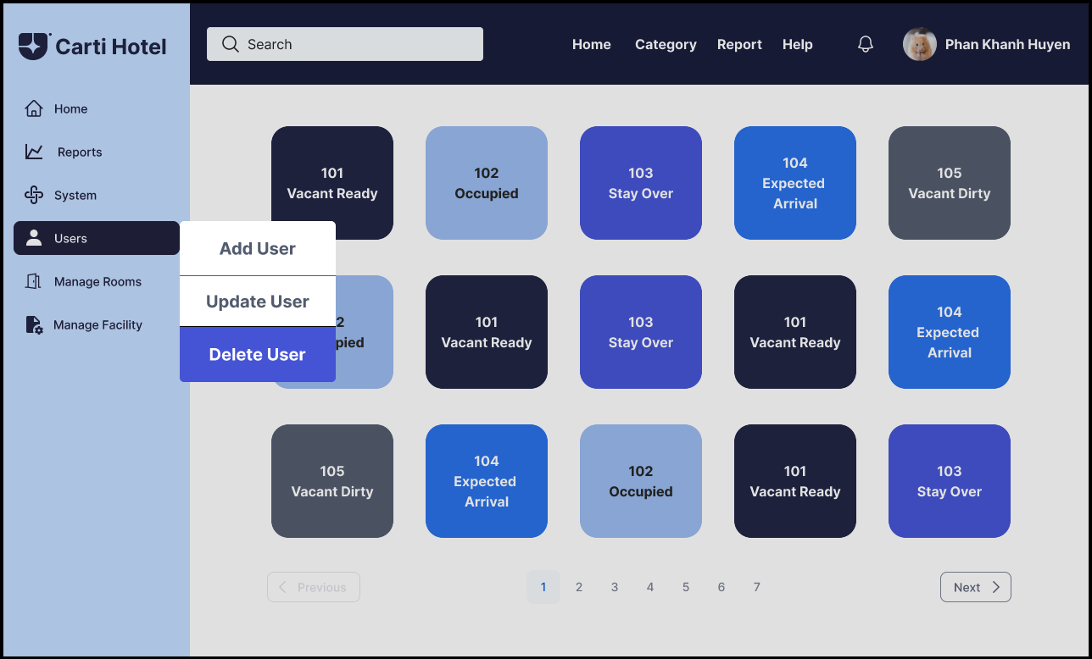

The list of users will appear and the admin will have to click on of the user row to delete that user.

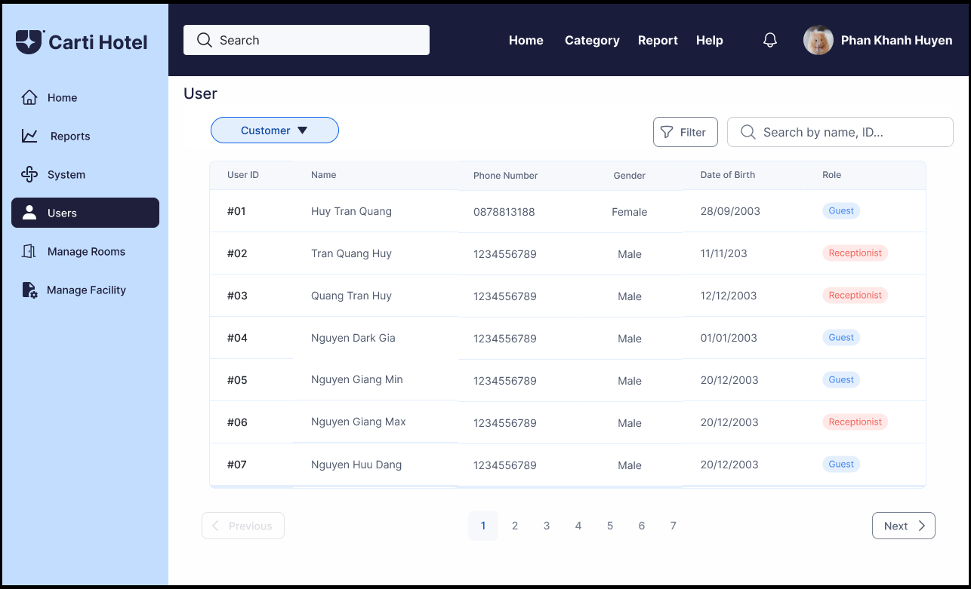

After clicking on one of the users which he or she wants to delete, the message box will appear and click “Yes” to confirm deleting a user from the list or click “Cancel”.

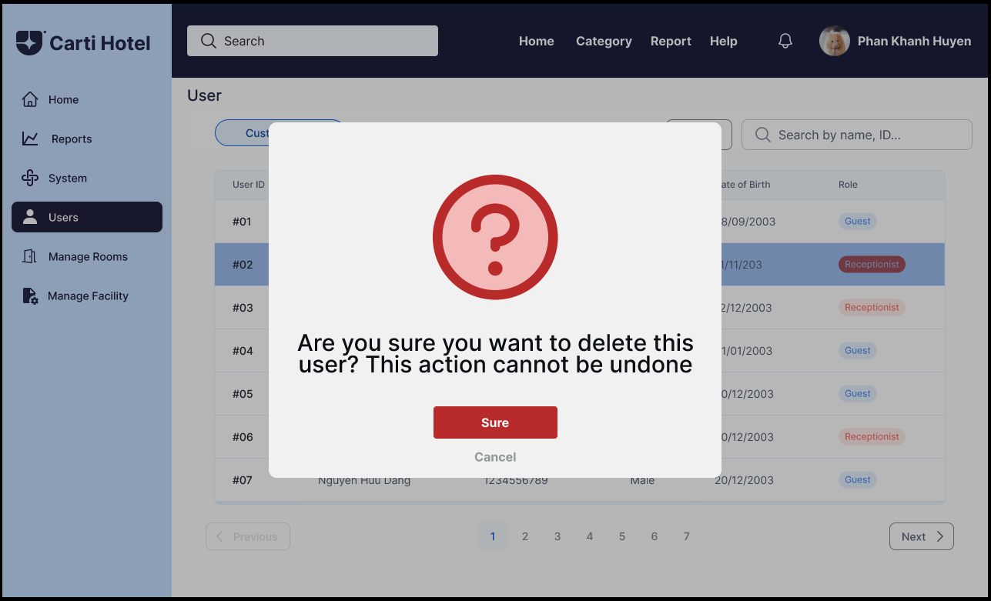

A message box notifying successful deletion will then appear:

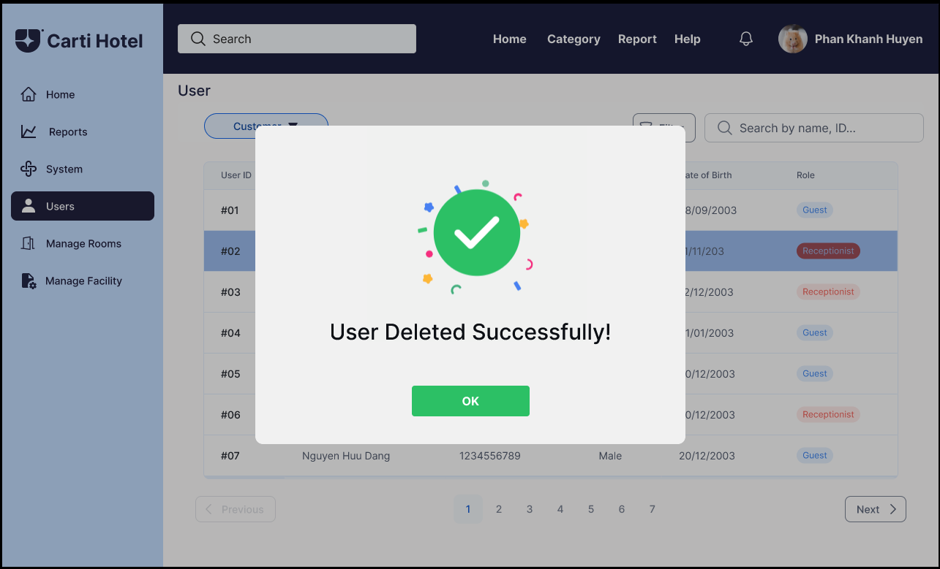

To update the user, the admin clicks on the Users Button.



Then the admin will need to choose the Update User button and is directed to the user listing page.

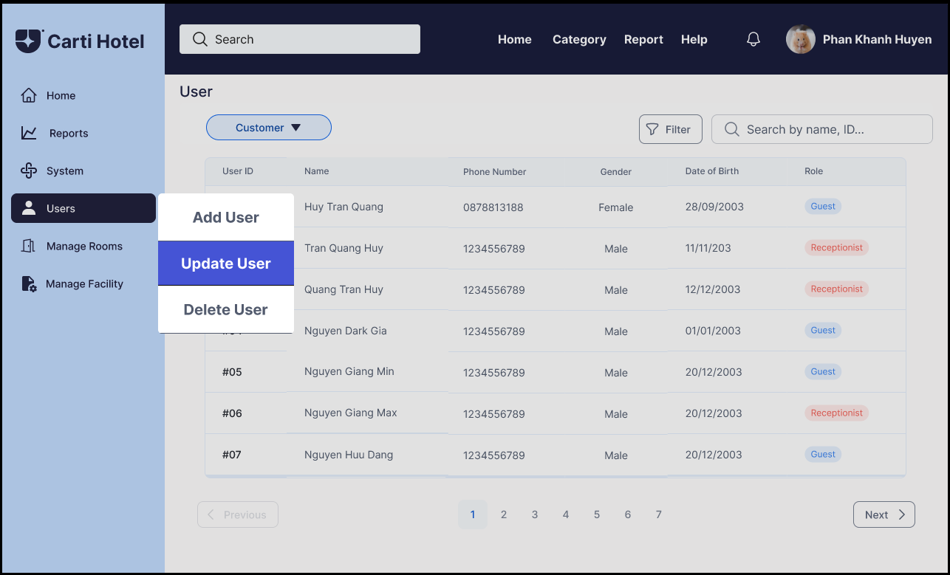

The list of users will appear on the screen of the admin page.

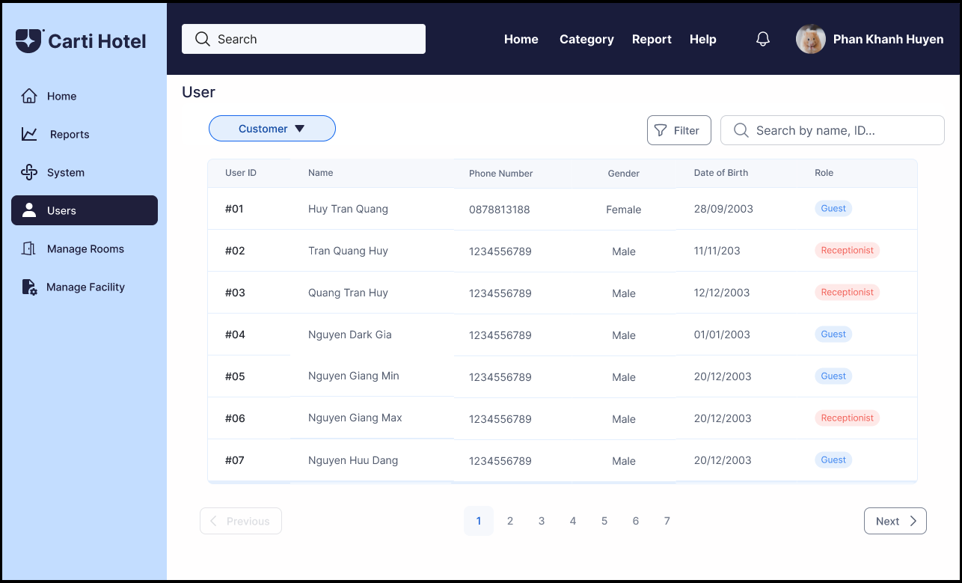

Clicking on one of the user rows will direct the admin to the update user page.

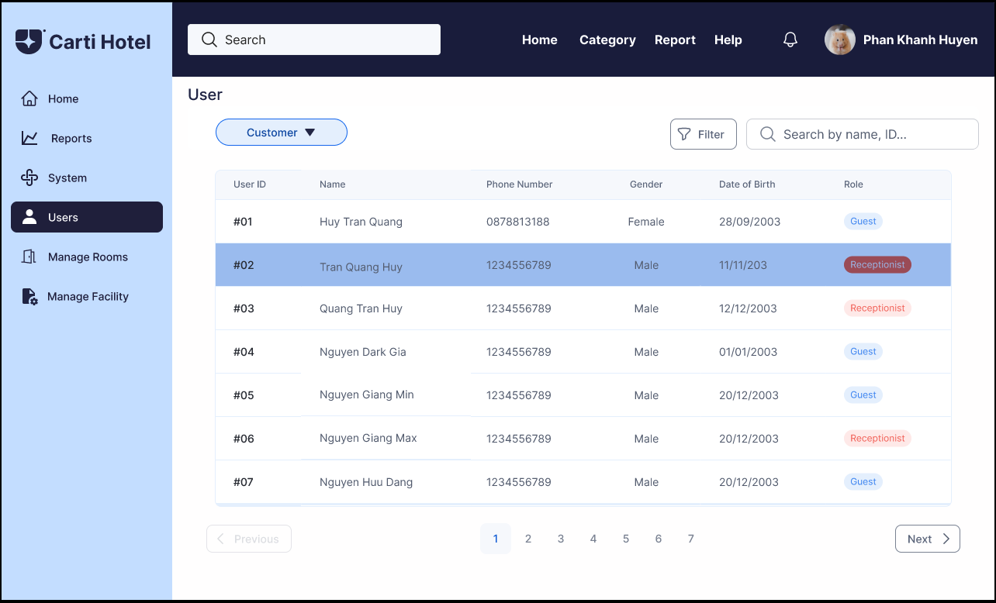

In this step, the admin can change the information of the user in each field.

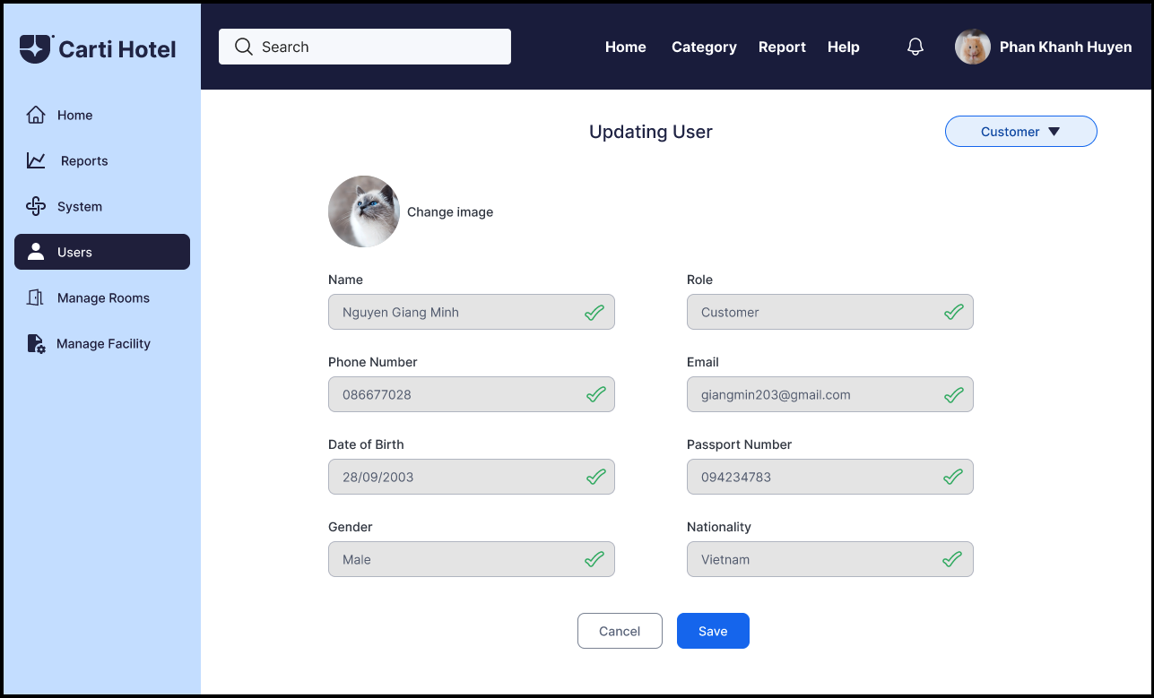

To finish updating the user’s information, click the Save Button, and a success message will be shown if nothing goes wrong.

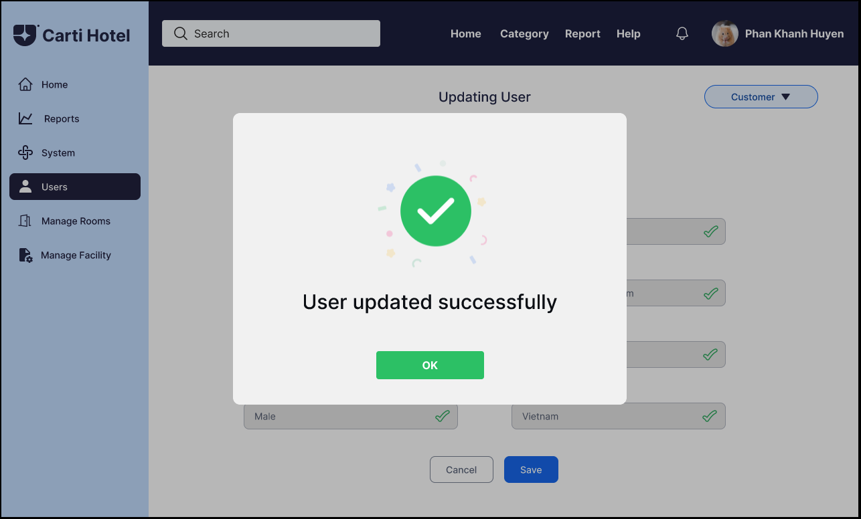

Otherwise, an error message will be shown, and notifying the admin which input was invalid.

